Saint Charles’ Primary School and LCR

DIGITAL LEARNING STRATEGY

Revised March 2022

‘Scotland’s learners live in a world that is changing at a rapid pace..... We know that many of our children and young people will be employed in jobs that do not exist yet, and that the need for digital skills will only become more pronounced in the future.'
Consultation on the development of a Digital Learning and Teaching Strategy for Scotland.

Saint Charles’ Primary School and L.C.R.
DIGITAL LEARNING STRATEGY

OUR VISION
In St Charles’ Primary and LCR, we are fully committed to raising attainment, ensuring equity and empowering learners through the use of Digital Learning and Technologies. With regular access to a range of devices and software we will develop, support, supplement and enhance the learning and teaching experiences of our pupils. We aim to develop digital capabilities and ensure that they are given opportunities to develop the knowledge and skills needed for learning, life and work. Digital Technologies are and will continue to be the golden thread running through our School Improvement Plan.

OUR AIM
Our aim is to create the conditions necessary to realise our vision and unlock the potential of digital technology in our school. The digital competencies wheel will be used as a self-evaluation tool in assessing our progress and next steps.

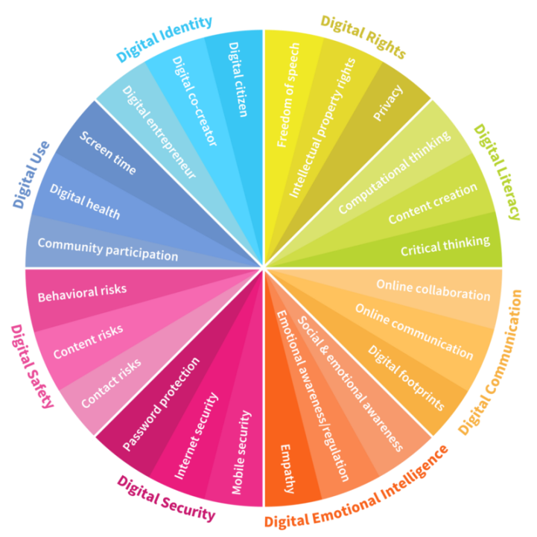

OUR DIGITAL LEARNERS
In line with the key objectives of the Digital Learning and Teaching strategy for Scotland (2016), we aim to ensure that digital technology is a central consideration in all areas of curriculum and assessment delivery.
Our framework supports teachers in planning progressive, cohesive and engaging programmes of work in the use of digital technologies to develop knowledge and skills in Computer Science, and through digital technologies to enhance creativity, collaboration and innovation in all curricular areas, ensuring opportunities for personalisation and choice. Teachers plan and assess learning and teaching in accordance with Experiences and Outcomes, and Benchmarks, using progression pathways. Digital technologies are used by teachers to present work, support and enhance learning and teaching, and to consolidate and assess knowledge and skills of all pupils, with appropriate support and differentiation built in. Pupils with ASN will use appropriate technologies, identified by individual plans when necessary and where possible technology employed to remove any barriers to learning.
OUR DIGITAL LEADERS
Pupil Digital Leaders will be chosen from P6 and 7 to form a Pupil Voice group. They will be interviewed at the start of P6 by existing digital leaders and join this group for 2 years. They will be responsible for organising and leading whole school national events, including safer internet day and computer science week, sharing skills and knowledge and supporting peers and teachers in the use of digital technologies.

CYBER RESILIENCE AND INTERNET SAFETY
21st century life presents dangers including violence, racism and exploitation from
which pupils need to be reasonably protected. At an appropriate age and maturity they will need to learn to recognise and avoid these risks to become “internetwise” and ultimately good “digital citizens”. Schools need to perform risk assessments on the technologies within their school to ensure that they are fully aware of and can mitigate against the potential risks involved with their use. Pupils need to know how to cope if they come across inappropriate material or situations online.

DENI E Safety Guidance, Circular number 2013/25

All pupils will be made aware of issues related to online safety, sharing personal information, cyber bullying and safe use of social media. The whole school will take part in local and national events related to safe and appropriate use of Digital Technologies, such as safer internet day. All staff will undertake appropriate up to date data protection training. There will be an e-safety display prominent in the digital Learning Suite, with children encouraged to regularly read it.

OUR STAFF
In line with the key objectives of the Digital Learning and Teaching strategy for Scotland (2016), we aim to develop the skills and confidence of teachers.
All members of staff are given the opportunities to continually develop and enhance their knowledge and skills in this continually developing and changing area. This is done through external and internal training events, and through sharing good practice within our school and cluster.

DIGITAL LEADER FOR LEARNING AND TEACHING
Roles and responsibilities will be allocated by HT as appropriate with reference to SIP, local and National priorities. The Digital Leader of Learning and Digital Working Party will take leading roles.
The Digital Leaders of Learning are responsible for organising cluster events to ensure parity across the schools.

Our Community and Communication

We are committed to enhancing our communication with parents / carers and partner agencies through the use of Digital Technologies and Social Media. We aim to reduce paper communication to a minimum. The majority of information and communications are shared through Seesaw, Twitter, Facebook and the School Website.

Measuring Impact

Managing Technology

Financial Sustainability

